Earlier we have seen for a technique finding a new feature or direction which was finding the direction where the variance was maximum, in this we will see a new technique called **distance minimization.**

**Objective:** In this technique the objective is to find the direction from which the distance (di) is minimum from (xi).

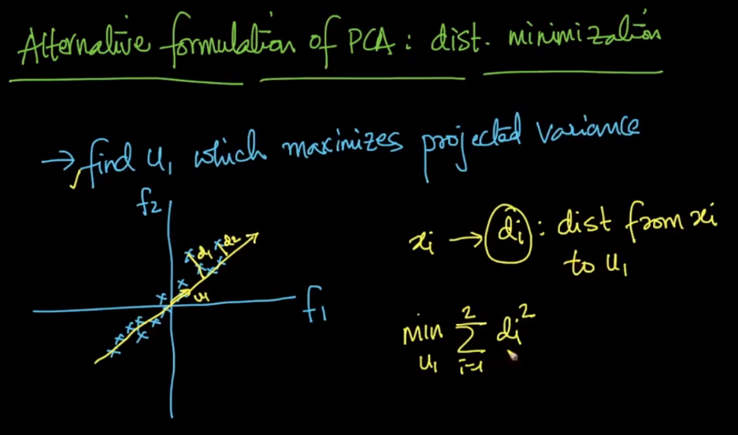

How we find distance of xi and u1. Since the projection of xi on u1 forms a right angle triangle so we can apply Pythagoras to find di.

The calculation is given in below fig.

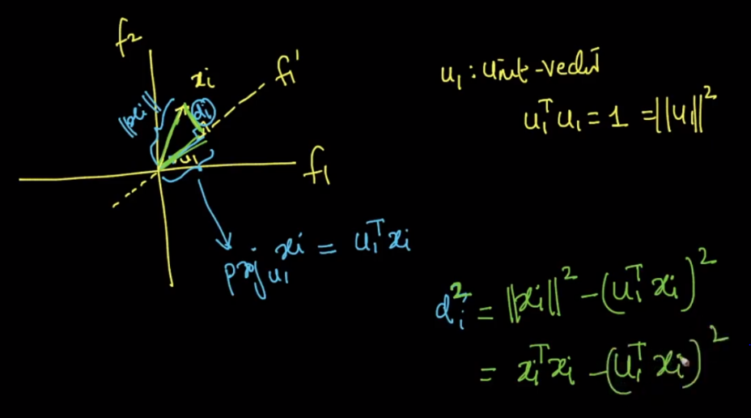

Now our ultimate aim is to find a direction u1 such that it has minimum distance from xi, given a constraint that uTu = 1

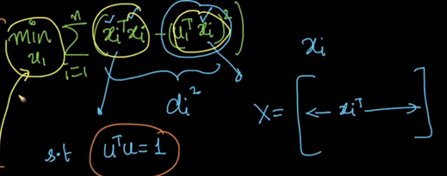

We’ve seen two different techniques for PCA, one is distance minimization PCA and other is variance maximization PCA, and eventually both lead to the same u1.

